Pub Grub Classics
Served Monday-Sunday all day.
 |  | Small | Large
Homemade Steak and Ale Pie  Served with Homemade Chips and Mushy Peas |  |  | £17.95
Mince and Dumplings  Served with Mash & seasonal Vegetables |  | £10.95 | £13.95
10oz Sirloin Steak (GF)  Served pan seared to your liking; basted in garlic & parsley butter with a grilled tomato, flat cap mushroom, homemade chips and homemade onion rings  Choose a sauce from Diane, Peppercorn or blue cheese for £4.95 |  |  | £19.95
Grilled Gammon (GF)  Served with egg or pineapple. homemade chips and garden Peas |  | £11.95 | £14.95
Homemade Curry of the day |  | Please ask Server
Traditional Fish and Homemade Chips  Served with Homemade Chips and a choice of Garden or Mushy Peas |  | £13.95 | £18.95
Breaded Wholetail Scampi  Breaded Fried Scampi served with homemade chunky chips with a choice of Mushy or Garden Peas |  | £11.95 | £16.95
Chicken Fajitas  Served with sour cream, homemade salsa, and cheese.  Add king prawns. |  |  | £15.95  £3.00
Vegetarian Fajitas  Served with sour cream, homemade dry salsa, and cheese |  |  | £12.95

The Pride of Teesside – The Parmo
Served Monday-Sunday all day.

 |  | Small | Large
Classic Parmesan  Served with Homemade Chips and Salad |  | £12.95 | £17.95
Pulled Pork Parmesan  Topped with bbq pulled pork. Served with Homemade Chips & Salad  Hot Shot Parmesan  Topped with Pepperoni, Jalapenos & Chilli Flakes. Served with Homemade Chips and Salad |  | £13.95  £13.95 | £18.95  £17.95
Black Pudding Parmesan  Topped with black pudding. Served with Homemade Chips and Salad. |  | £13.95 | £17.95
Kiev Fungi Parmesan  Topped with mushrooms in garlic butter. Served with Homemade Chips and salad |  | £13.95 | £17.95
Bolognese Parmesan  Topped with Bolognese. Served with Homemade Chips and Salad |  | £13.95 | £17.95
Veggie Parmesan  Hash Brown Base Parmo, topped with Onion & Bell Peppers. Served with Homemade Chips and Salad  Fajita Parmesan  Topped with chicken Fajita, spice mix, peppers and onions. Served with Homemade Chips and Salad. | V | £13.95  £14.95 | 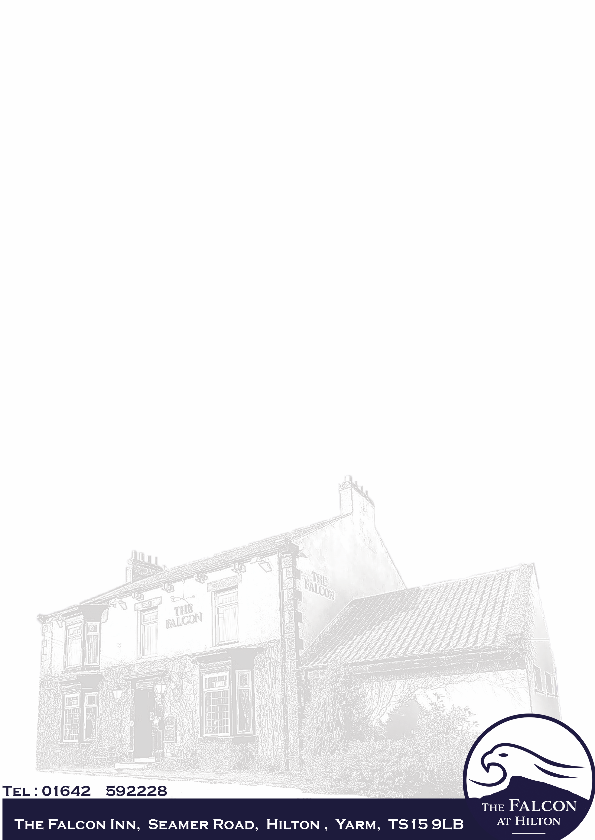  £18.95
Southern Fried Chicken Parmesan  Classic chicken parmesan with a twist. Southern fried chicken in herbs and spices. Accompanied with a Cajun sauce. Served with Homemade Chips and Salad  Pesto parmesan  Topped with homemade basil pesto, cherry tomatos, and fresh basil served with homemade chips and salad |  | £14.95  £13.95 | £17.95  £17.95

